PHASE 4 — WORKFLOW & AUTOMATION DEVELOPMENT
4.1 Introduction
The fourth phase of the project focuses on developing the workflow and automation process for the Car Rental Request in ServiceNow.
The workflow automates the complete request lifecycle after an employee submits the Car Rental Request through the Service Catalog. It manages approval, fulfillment, task creation, notifications, and request completion without requiring manual coordination between the requester, manager, and Transport Team.

4.2 Objectives
The main objectives of this phase are:
- Automate the Car Rental Request approval process.
- Route approved requests to the Transport Team.
- Automatically create a Catalog Task for fulfillment.
- Configure appropriate approval conditions.
- Send email notifications during important workflow stages.
- Control the request lifecycle from submission to completion.
- Reduce manual follow-up and improve request tracking.

4.3 Workflow Overview
The implemented workflow follows this sequence:
Employee submits request
↓
Request and RITM are created
↓
Manager Approval
↓
Approval Decision
↓
If Approved → Transport Team
↓
Catalog Task Creation
↓
Transport Team fulfills request
↓
Request is completed
↓
Email notifications are generated
If the request is rejected, the workflow follows the rejection path and the request does not proceed to fulfillment.

4.4 Workflow Trigger
The workflow is triggered when a user submits the Car Rental Request catalog item.
The submitted information includes:
- Requested Date
- Pickup Location
- Drop Location
- Duration
- Car Type
- Reason
After submission, ServiceNow creates the corresponding Request (REQ) and Requested Item (RITM) records.
The workflow then starts processing the RITM.

4.5 Approval Automation
The first major automation step is the manager approval.
The workflow sends the request to the appropriate manager/approver.
Approval Process
- The employee submits the Car Rental Request.
- The RITM is generated.
- The workflow determines the required approver.
- An approval request is generated.
- The manager reviews the request.
- The manager either:
  - Approves the request, or
  - Rejects the request.
Approval Result
If Approved:
The workflow continues to the fulfillment stage.
If Rejected:
The workflow follows the rejection path and the request does not proceed to normal fulfillment.

4.6 Approval Configuration
The workflow uses an approval activity to manage the manager approval.
During testing, an approval issue was encountered where the approval activity was skipped because there was no valid approver.
This was resolved by configuring a valid manager/approver for the request.
After correction, the approval activity successfully waited for the manager's decision.

4.7 Transport Team Assignment
After the manager approves the request, the workflow moves the request toward fulfillment.
The request is routed to the Transport Team.
The Transport Team is responsible for:
- Reviewing the rental request.
- Checking the requested vehicle details.
- Processing the transportation requirement.
- Assigning an appropriate vehicle.
- Completing the fulfillment task.

4.8 Catalog Task Creation
A major automation implemented in this phase is the automatic creation of a Catalog Task.
After approval, ServiceNow creates a Catalog Task for the Transport Team.
The Catalog Task contains the information required to fulfill the request.
Task Flow
Approved RITM
↓
Catalog Task Created
↓
Assignment Group = Transport Team
↓
Transport Team Processes Request
↓
Task Completed
This eliminates the need for the requester to manually create a separate task for the Transport Team.

4.9 Catalog Task Assignment
The Catalog Task is assigned to the appropriate assignment group:
Assignment Group: Transport Team
The Transport Team can then access the task and process the car rental request.
During testing, it was observed that the workflow could wait when the assignment group was configured but the Assigned To field was empty. The workflow was subsequently configured/tested so that the Catalog Task was successfully created for fulfillment.

4.10 Email Notification Automation
Email notifications are also part of the automated workflow.
Notifications are generated for relevant workflow events, such as:
- Request submission
- Approval-related events
- Request processing
- Fulfillment/task-related events
- Request completion
The notifications help users track the progress of their car rental request without manually checking the system repeatedly.
During final testing, the project successfully generated the expected email notifications.

4.11 Request Completion
After the Transport Team completes the Catalog Task, the request proceeds toward completion.
The final lifecycle is:
Request Submitted
→ Pending Approval
→ Approved
→ Catalog Task Created
→ Transport Team Fulfillment
→ Task Completed
→ Request Completed
The completed request can be tracked through the ServiceNow records.

4.12 Workflow Conditions
The workflow uses conditions to control the next step based on the request status.
Condition | Workflow Action
Request submitted | Start workflow
Approval pending | Wait for manager
Approved | Continue to fulfillment
Rejected | Stop/rejection path
Catalog Task created | Assign to Transport Team
Task completed | Continue toward completion
Request completed | End workflow
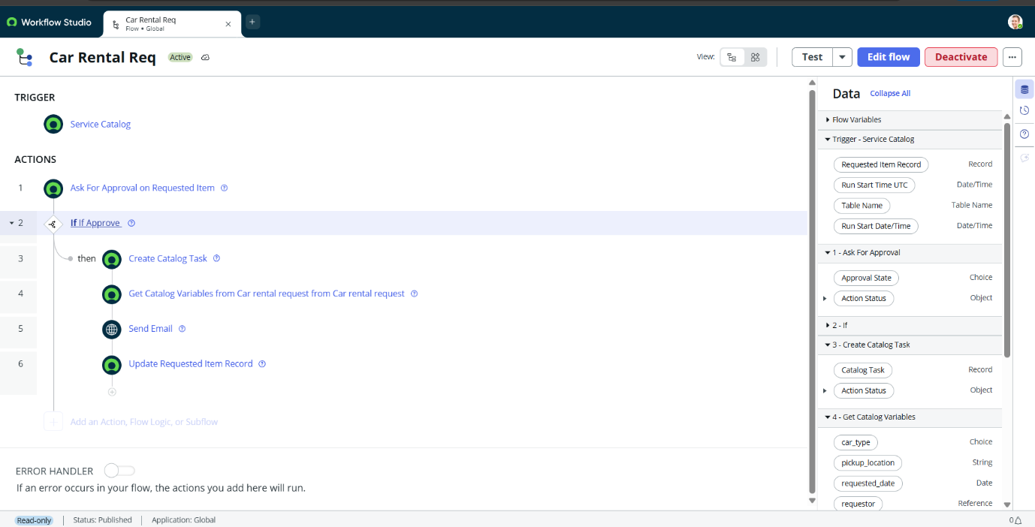

4.13 Automation Components Used
The following ServiceNow components were used in this phase:
- Workflow
- Approval activity
- Approval conditions
- Catalog Task
- Assignment Group
- Transport Team
- Request/RITM records
- Email Notifications
- Workflow conditions
- Request state management

4.14 Testing
The workflow was tested using different scenarios.
Test Case 1 — Request Submission
Input: Valid Car Rental Request
Expected Result:
Request and RITM should be created and workflow should start.
Result: Passed

Test Case 2 — Manager Approval
Input: Valid request awaiting approval
Expected Result:
Approval should be generated for the appropriate manager.
Result: Passed

Test Case 3 — Approval
Input: Manager approves the request.
Expected Result:
Workflow should proceed to fulfillment.
Result: Passed

Test Case 4 — Catalog Task Creation
Input: Approved request
Expected Result:
Catalog Task should automatically be created and routed to the Transport Team.
Result: Passed

Test Case 5 — Email Notification
Input: Workflow reaches configured notification events.
Expected Result:
Email notification should be generated.
Result: Passed

Test Case 6 — Request Completion
Input: Transport Team completes the Catalog Task.
Expected Result:
Request should proceed to the completed state.
Result: Passed
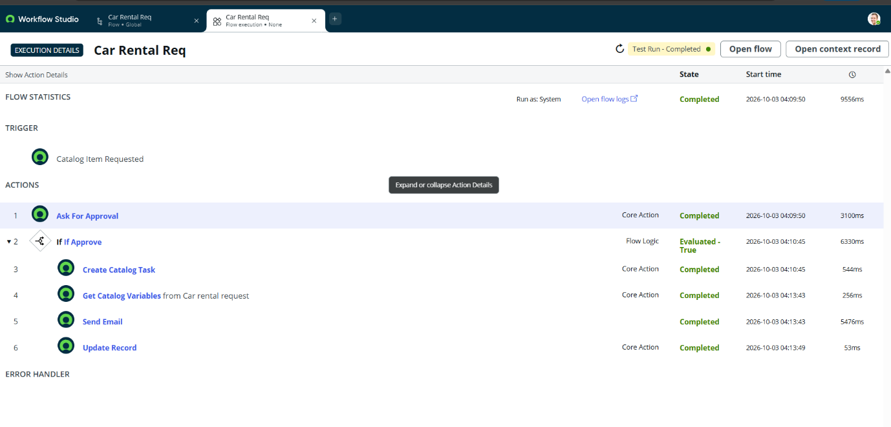

4.15 Error Handling
During workflow development, the following issues were identified and resolved:
Issue 1 — No Valid Approver
Problem:
The approval activity was skipped because no valid approver was available.
Resolution:
A valid manager/approver was configured for the request.

Issue 2 — Workflow Waiting During Fulfillment
Problem:
The workflow could remain waiting when the Transport Team assignment group was selected but the task did not have an appropriate assignee.
Resolution:
The fulfillment/task configuration was corrected and tested until the Catalog Task was successfully created and processed.

4.16 Final Workflow Implementation
The completed automation can be represented as:
Employee
↓
Car Rental Request
↓
Service Catalog
↓
Request / RITM
↓
Manager Approval
↓
Approved?
Yes │ No
↓
Transport Team
↓
Catalog Task
↓
Vehicle Fulfillment
↓
Task Completion
↓
Request Completion
↓
Email Notification

4.17 Deliverables
The following deliverables were completed in Phase 4:
- Car Rental workflow
- Manager approval process
- Approval decision handling
- Transport Team routing
- Catalog Task automation
- Fulfillment process
- Email notification configuration
- Workflow testing
- Error handling and corrections
- End-to-end workflow validation

